COURSE: CSA1715-Artificial Intelligence Name: S VIGNESH
DATE: 23.07.2026 Reg.no: 192512378

EXPERIMENT 4: Write a Python Program for Crypt-Arithmetic Problem
Aim
To solve the Crypt-Arithmetic problem SEND + MORE = MONEY by assigning unique digits to each letter using a brute-force search method.

Algorithm
Step 1: Start the program.
Step 2: Identify all the unique letters in the given Crypt-Arithmetic problem.
Step 3: Generate different digit combinations for the unique letters.
Step 4: Assign one digit to each letter.
Step 5: Ensure that no two letters are assigned the same digit.
Step 6: Ensure that the first letters S and M are not assigned zero.
Step 7: Form the numbers SEND, MORE, and MONEY using the assigned digits.
Step 8: Check whether SEND + MORE = MONEY.
Step 9: Display the letter-to-digit assignments and the solution if the condition is satisfied.
Step 10: Stop the program.

Program
from itertools import permutations

# Digits from 0 to 9
digits = range(10)

# Generate all possible digit arrangements
for p in permutations(digits, 8):

S, E, N, D, M, O, R, Y = p

# First digit of a number cannot be zero
if S == 0 or M == 0:
continue

# Form the numbers
SEND = 1000 * S + 100 * E + 10 * N + D
MORE = 1000 * M + 100 * O + 10 * R + E
MONEY = 10000 * M + 1000 * O + 100 * N + 10 * E + Y

# Check the Crypt-Arithmetic condition
if SEND + MORE == MONEY:

print("Solution Found!")
print("-------------------------")

print("S =", S)
print("E =", E)
print("N =", N)
print("D =", D)
print("M =", M)
print("O =", O)
print("R =", R)
print("Y =", Y)

print("\nCalculation:")
print(" ", SEND)
print("+ ", MORE)
print("-------")
print(" ", MONEY)

break
else:
print("No solution exists.")

Output
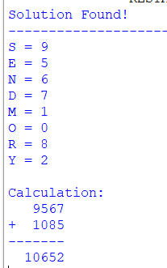

Result
Thus, the Crypt-Arithmetic problem SEND + MORE = MONEY was successfully solved using the brute-force search method, and the correct digit assignment for each letter was obtained successfully.

EXPERIMENT 5: Write a Python Program for Missionaries and Cannibals Problem
Aim
To solve the Missionaries and Cannibals problem using the Breadth-First Search algorithm while ensuring that the missionaries are never outnumbered by the cannibals on either side of the river.
Algorithm
Step 1: Start the program.
Step 2: Represent each state using the number of missionaries, cannibals and the boat position.
Step 3: Set the initial state as three missionaries and three cannibals on the left bank.
Step 4: Set the goal state as all missionaries and cannibals on the right bank.
Step 5: Define all possible combinations of people who can travel in the boat.
Step 6: Generate new states by moving people from one bank to another.
Step 7: Check whether each generated state is valid and safe.
Step 8: Use Breadth-First Search to explore all valid states.
Step 9: Continue the search until the goal state is reached.
Step 10: Display the sequence of states and stop the program.
Program
from collections import deque

# Check whether a state is valid
def is_valid(state):
m_left, c_left, boat = state

m_right = 3 - m_left
c_right = 3 - c_left

# Check the range of missionaries and cannibals
if not (0 <= m_left <= 3 and 0 <= c_left <= 3):
return False

# Check safety on the left bank
if m_left > 0 and c_left > m_left:
return False

# Check safety on the right bank
if m_right > 0 and c_right > m_right:
return False

return True

# Solve using Breadth-First Search
def solve():
initial_state = (3, 3, 0)
goal_state = (0, 0, 1)

# Possible boat movements
moves = [
(1, 0),
(2, 0),
(0, 1),
(0, 2),
(1, 1)
]

queue = deque()
queue.append((initial_state, [initial_state]))

visited = {initial_state}

while queue:
current_state, path = queue.popleft()

if current_state == goal_state:
return path

m_left, c_left, boat = current_state

for missionaries, cannibals in moves:

# Boat moves from left to right
if boat == 0:
new_state = (
m_left - missionaries,
c_left - cannibals,
1
)

# Boat moves from right to left
else:
new_state = (
m_left + missionaries,
c_left + cannibals,
0
)

if is_valid(new_state) and new_state not in visited:
visited.add(new_state)
queue.append((new_state, path + [new_state]))

return None

# ---------------- MAIN PROGRAM ----------------

solution = solve()

if solution:
print("Solution Found!")
print("---------------------------------------------")
print("Step\tLeft Bank\tBoat\tRight Bank")
print("---------------------------------------------")

for step, state in enumerate(solution):
m_left, c_left, boat = state

m_right = 3 - m_left
c_right = 3 - c_left

boat_position = "Right" if boat == 1 else "Left"

print(
step,
f"\tM={m_left}, C={c_left}",
f"\t{boat_position}",
f"\tM={m_right}, C={c_right}"
)
else:
print("No solution exists.")
Output:
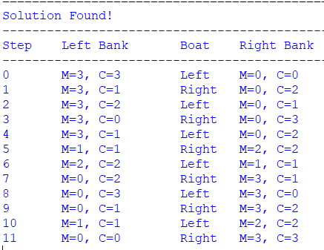

Result
Thus, the Missionaries and Cannibals problem was successfully solved using the Breadth-First Search algorithm, and all three missionaries and three cannibals were safely moved from the left bank to the right bank.

EXPERIMENT 6: Write a Python Program for Vacuum Cleaner Problem
Aim
To implement the Vacuum Cleaner problem using a simple reflex agent that cleans two rooms based on their current condition.
Algorithm
Step 1: Start the program.
Step 2: Read the initial location of the vacuum cleaner.
Step 3: Read the condition of Room A and Room B.
Step 4: Check the condition of the room where the vacuum cleaner is located.
Step 5: If the current room is dirty, clean the room.
Step 6: Move the vacuum cleaner to the other room.
Step 7: Check whether the other room is dirty.
Step 8: Clean the room if it is dirty.
Step 9: Display every action performed by the vacuum cleaner.
Step 10: Stop the program when both rooms are clean.

Program
# Vacuum Cleaner Problem

def vacuum_cleaner(location, room_a, room_b):
print("\nInitial State")
print("Vacuum Location:", location)
print("Room A:", room_a)
print("Room B:", room_b)

steps = 0

while room_a == "Dirty" or room_b == "Dirty":

# Vacuum is in Room A
if location == "A":

if room_a == "Dirty":
print("\nRoom A is dirty.")
print("Action: Clean Room A")
room_a = "Clean"
steps += 1
else:
print("\nRoom A is already clean.")

print("Action: Move from Room A to Room B")
location = "B"
steps += 1

# Vacuum is in Room B
else:

if room_b == "Dirty":
print("\nRoom B is dirty.")
print("Action: Clean Room B")
room_b = "Clean"
steps += 1
else:
print("\nRoom B is already clean.")

if room_a == "Dirty":
print("Action: Move from Room B to Room A")
location = "A"
steps += 1

print("\nFinal State")
print("Vacuum Location:", location)
print("Room A:", room_a)
print("Room B:", room_b)
print("Total Actions:", steps)
print("\nBoth rooms are clean.")

# ---------------- MAIN PROGRAM ----------------

location = input("Enter vacuum location (A/B): ").upper()

room_a = input("Enter condition of Room A (Clean/Dirty): ").capitalize()
room_b = input("Enter condition of Room B (Clean/Dirty): ").capitalize()

# Validate location
if location not in ["A", "B"]:
print("Invalid vacuum location.")

# Validate room conditions
elif room_a not in ["Clean", "Dirty"] or room_b not in ["Clean", "Dirty"]:
print("Invalid room condition.")

else:
vacuum_cleaner(location, room_a, room_b)

Sample Input
Enter vacuum location (A/B): A
Enter condition of Room A (Clean/Dirty): Dirty
Enter condition of Room B (Clean/Dirty): Dirty

Output
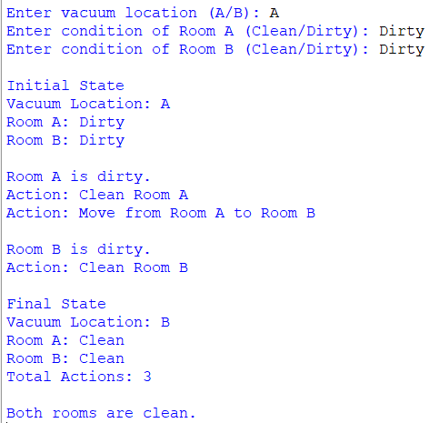

Result
Thus, the Vacuum Cleaner problem was successfully implemented using a simple reflex agent, and both Room A and Room B were cleaned successfully.

EXPERIMENT 7: Write a Python Program for Breadth-First Search
Aim
To implement the Breadth-First Search algorithm in Python and traverse all the vertices of a graph level by level.
Algorithm
Step 1: Start the program.
Step 2: Read the number of vertices and edges in the graph.
Step 3: Create an adjacency list to represent the graph.
Step 4: Read all the edges and add them to the adjacency list.
Step 5: Read the starting vertex for traversal.
Step 6: Insert the starting vertex into a queue and mark it as visited.
Step 7: Remove a vertex from the front of the queue and display it.
Step 8: Add all its unvisited adjacent vertices to the queue.
Step 9: Repeat the process until the queue becomes empty.
Step 10: Stop the program.

Program
from collections import deque

# Breadth-First Search function
def bfs(graph, start):
visited = set()
queue = deque([start])

visited.add(start)

print("\nBFS Traversal:")

while queue:
vertex = queue.popleft()
print(vertex, end=" ")

for neighbor in graph[vertex]:
if neighbor not in visited:
visited.add(neighbor)
queue.append(neighbor)

# ---------------- MAIN PROGRAM ----------------

graph = {}

vertices = int(input("Enter the number of vertices: "))

# Create an empty adjacency list
for i in range(vertices):
graph[i] = []

edges = int(input("Enter the number of edges: "))

print("Enter the edges:")

for i in range(edges):
u, v = map(int, input().split())

# Undirected graph
graph[u].append(v)
graph[v].append(u)

start = int(input("Enter the starting vertex: "))

# Validate starting vertex
if start not in graph:
print("Invalid starting vertex.")
else:
bfs(graph, start)
Sample Input
Enter the number of vertices: 6
Enter the number of edges: 6

Enter the edges:
0 1
0 2
1 3
1 4
2 5
4 5

Enter the starting vertex: 0

Output
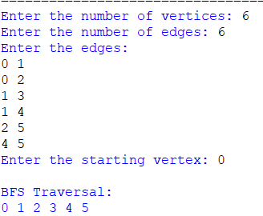

Result
Thus, the Breadth-First Search algorithm was successfully implemented in Python, and all the vertices of the graph were traversed level by level from the given starting vertex.

EXPERIMENT 8: Write a Python Program for Depth-First Search
Aim
To implement the Depth-First Search algorithm in Python and traverse all the vertices of a graph by exploring one path completely before moving to another path.
Algorithm
Step 1: Start the program.
Step 2: Read the number of vertices and edges in the graph.
Step 3: Create an adjacency list to represent the graph.
Step 4: Read the edges and store them in the adjacency list.
Step 5: Read the starting vertex for DFS traversal.
Step 6: Mark the starting vertex as visited.
Step 7: Display the current vertex.
Step 8: Recursively visit every unvisited adjacent vertex.
Step 9: Continue until all reachable vertices are visited.
Step 10: Stop the program.

Program
# Depth-First Search function
def dfs(graph, vertex, visited):
visited.add(vertex)
print(vertex, end=" ")

for neighbor in graph[vertex]:
if neighbor not in visited:
dfs(graph, neighbor, visited)

# ---------------- MAIN PROGRAM ----------------

graph = {}

vertices = int(input("Enter the number of vertices: "))

# Create an empty adjacency list
for i in range(vertices):
graph[i] = []

edges = int(input("Enter the number of edges: "))

print("Enter the edges:")

for i in range(edges):
u, v = map(int, input().split())

# Undirected graph
graph[u].append(v)
graph[v].append(u)

start = int(input("Enter the starting vertex: "))

# Validate the starting vertex
if start not in graph:
print("Invalid starting vertex.")
else:
visited = set()

print("\nDFS Traversal:")
dfs(graph, start, visited)

Sample Input
Enter the number of vertices: 6
Enter the number of edges: 6

Enter the edges:
0 1
0 2
1 3
1 4
2 5
4 5

Enter the starting vertex: 0

Output
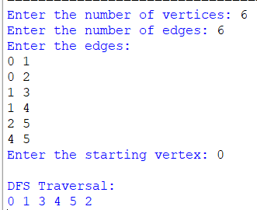
Result
Thus, the Depth-First Search algorithm was successfully implemented in Python, and all the reachable vertices of the graph were traversed by exploring each path deeply before backtracking.

